# Lab#8:

# Function overloading, Pass by reference

Total marks: 20 (10 each)

Submission deadline: 27th April, 2020, Sunday till 11:59pm

Submission guidelines:

* Put all your .cpp files in a folder. Zip that folder and name it with your roll number.
* Email the zipped folder at [**natalia@pucit.edu.pk**](mailto:natalia@pucit.edu.pk). You must put the **subject** of your email as:

**“Lab#8”**

* Students who are facing issues with their laptop or compiler can write the code on paper and send the screenshots, following the above guideline. Since your issue will be genuine therefore relaxation will be given accordingly. Don’t worry!

# Task 1: Pass by reference

Write a C++ program with two alternate functions as specified below that simply triple the variable count in the main.

* Function **tripleValueParam** that receives a copy of count as a parameter, triples the value and returns it to main
* Function **tripleRefParam** that receives address of count as a parameter and triples the value.

# Task 2: Function overloading

**For this task you need to know details about coordinates of console and some built-in functions. Pls see them below.**

**Coordinates of console screen:**

Your screen is divided into grid with x and y coordinates as shown below:

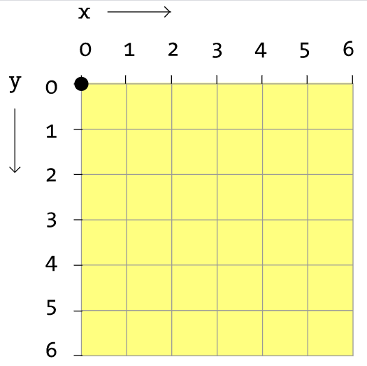

You already must have noticed that by default the cursor points at (0,0) coordinate. To move a cursor to a specific point, c++ has several built-in functions that can help you out. Let’s check the simple code that allows user to print anything at specific position (i.e. it allows to move the cursor to the specific point). For your convenience, following code is provided. You just need to know where you have to put your value for x and y coordinate. Ignore how the other things are defined and added.

Built-in library

#include<windows.h>

#include<iostream>

using namespace std;

HANDLE console = GetSte(STD_OUTPUT_HANDLE);

COORD CursorPosition;

int main()

{

CursorPosition.X = 2;

CursorPosition.Y = 3;

SetConsoleCursorPosition(console, CursorPosition);

cout << "XXX";

}

**Function defined n this library**

**You can supply your x and y coordinate point here in these variables. If you want to move cursor to (2,3) location, then that means you want your cursor to have 2 as its x coordinate and 3 as its y coordinate.**

**Simply put x coordinate location in** CursorPosition.X **and y location in** CursorPosition.Y

***Ignore the other details. No need to worry about it. Just know how to use it in moving cursor.***

**Built-in function that sets the cursor to your defined location (defined by CursorPosition)**

**You are required to use function overloading and implement two functions with draw functionality.**

1. **Draw with one argument**

This function will take integer width as an input and then print the line with that width. You can print the line using asterisk. (See sample output for reference)

1. **Draw with two arguments**

This function will take two integers: width and height as an input and then print the rectangle with that dimensions. You can print that using asterisk. (See sample output for reference)

Sample output is shown below. First you should call draw function to draw a line starting from 0,0 position. Then adjacent to that, print rectangle using above discussed functions.

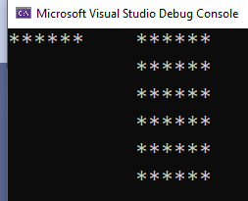

An incomplete code has been provided below. Fill in the code by adding the correct lines of code to generate the above output. Read the comments with the code to understand and see where to add the code.

#include<windows.h>

#include<iostream>

using namespace std;

HANDLE console = GetStdHandle(STD_OUTPUT_HANDLE);

COORD CursorPosition;

void draw(int w)

{

CursorPosition.X = 0;//setting x coordinate of a cursor to 0

CursorPosition.Y = 0;//setting y coordinate to 0

SetConsoleCursorPosition(console, CursorPosition);

//********Add code here******//

//add a code that prints the line of asteriks with width w

}

void draw(int l,int w)

{

//********Add code here******//

//add a code that prints the rectangle of asteriks with length l and width w

// the rectangle must be drawn adjacent to the line

//for that, set the cursor position

// you might need to set x and y positions as:

//CursorPosition.X = //********Add code here******//

// CursorPosition.Y = //********Add code here******//

// SetConsoleCursorPosition(console, CursorPosition);

//use these above 3 lines in your logic..these lines will

//help in reaching a specific location on the screen

}

int main()

{

//********Add code here******//

//call a function to draw a line, passing the width of your choice

//********Add code here******//

//call a function to draw a line, passing the width of your choice

return 0;

}